Maximum marks for Assignment: _________6______ Assignment Declaration Date:____________
Assignment Submission Date (on or before):______________________________
Assignment assessment declaration Date by faculty (on or before):________________________
Question NO | Question Statement | Level of mapping and Number |  |  | Blooms Level | Marks
Question NO | Question Statement | CO | PO | PSO
Q1. | With the help of neat diagram Describe brief history of the selenium tool. | CO4 | PO1 |  | 1 | 5
Q2 | Explain in details selenium tool suite, What are the different Selenium components | CO4 | PO1,PO2 |  | 2 | 4
Q3 | What is Selenium? List features provided by an Selenium IDE | CO4 | PO2,PO3 |  | 2 | 4
Q4 | Describe selenium Web Driver architecture with the help of neat diagram | CO4 | PO1 |  | 2 | 6
Q5 | What is selenium Grid? What is the purpose of selenium Grid? | CO4 | PO2,PO3 |  | 2 | 4
Q.6 | What is Selenium RC? Explain its features | CO4 | PO4 |  | 2 | 4
Q.7 | What are the limitations of Selenium | CO4 | PO1 |  | 2 | 4
Q.8 | List automation tools for software testing. Describe QTP in detail. | CO4 | PO1,PO3 |  | 2 | 5
Q.9 | What are selenium test design considerations? | CO4 | PO1,PO3 |  | 2 | 4
Blooms level no | Blooms Taxonomy terms
6 | 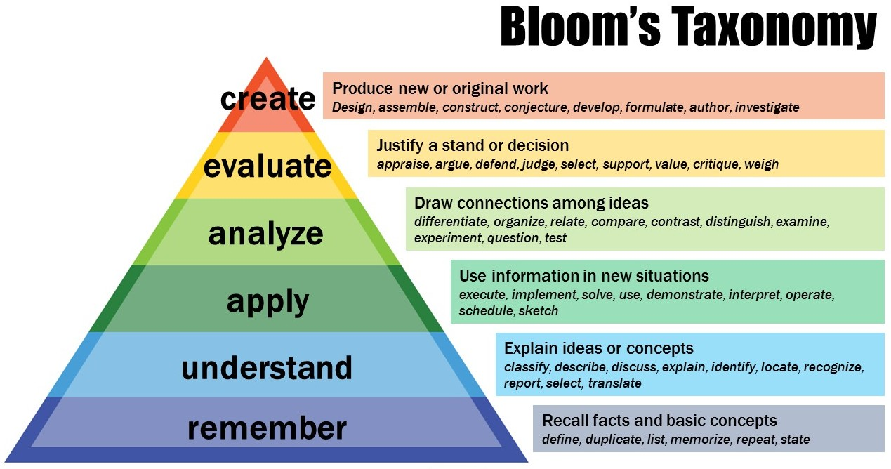
5
4
3
2
1

Subject In-charge HOD

